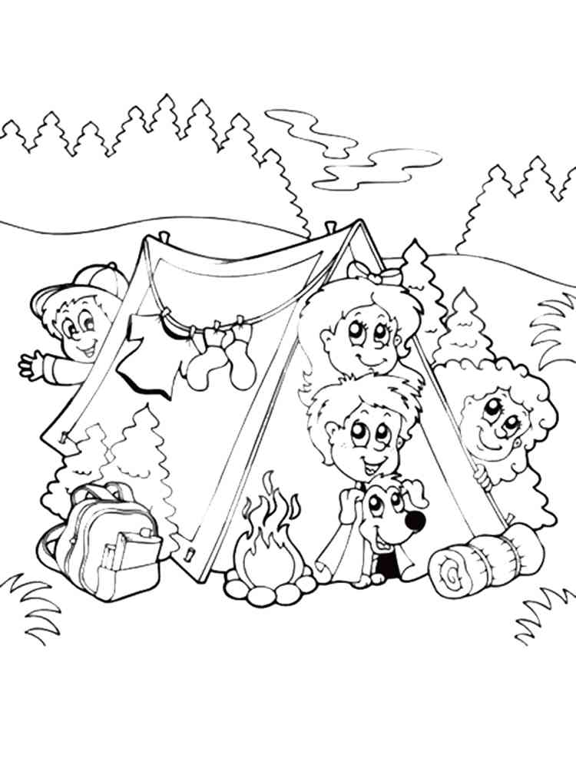**NAAM:………………………………………………………………………………………………………..**

**AFDELING:………………………………………………………………………………………………….**